EasySpotOps
EasySpotOps Resident User Manual
Visual guide for residents and other approved users connecting to a property, registering vehicles, and viewing parking status.
Parking Operations Made Simple

Visual Step-by-Step Guide
- Welcome - what residents can do
- Sign in
- Connecting to a property
- Using an invite/access code
- Requesting access
- Checking request status
- Registering a vehicle
- Viewing parking status
- Submitting requests
- Mobile tips
- Troubleshooting

Welcome - what residents can do
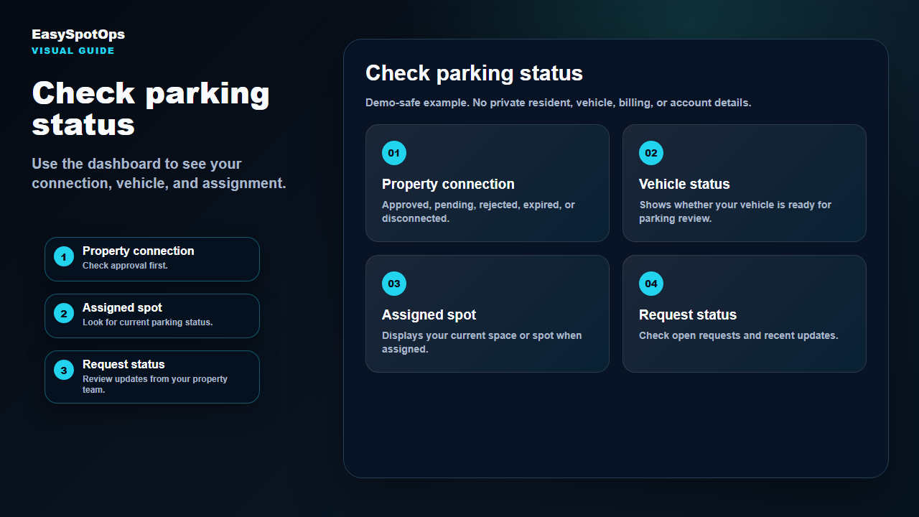
Screenshot or illustrated EasySpotOps product card with demo-safe sample data.
Look for this  Request property access. | What to click  Register vehicle information. | What happens next  View parking status and request updates.
What this section does
EasySpotOps helps you connect to a property, share vehicle details, view parking status, and submit requests when those options are enabled for your property.

Sign in
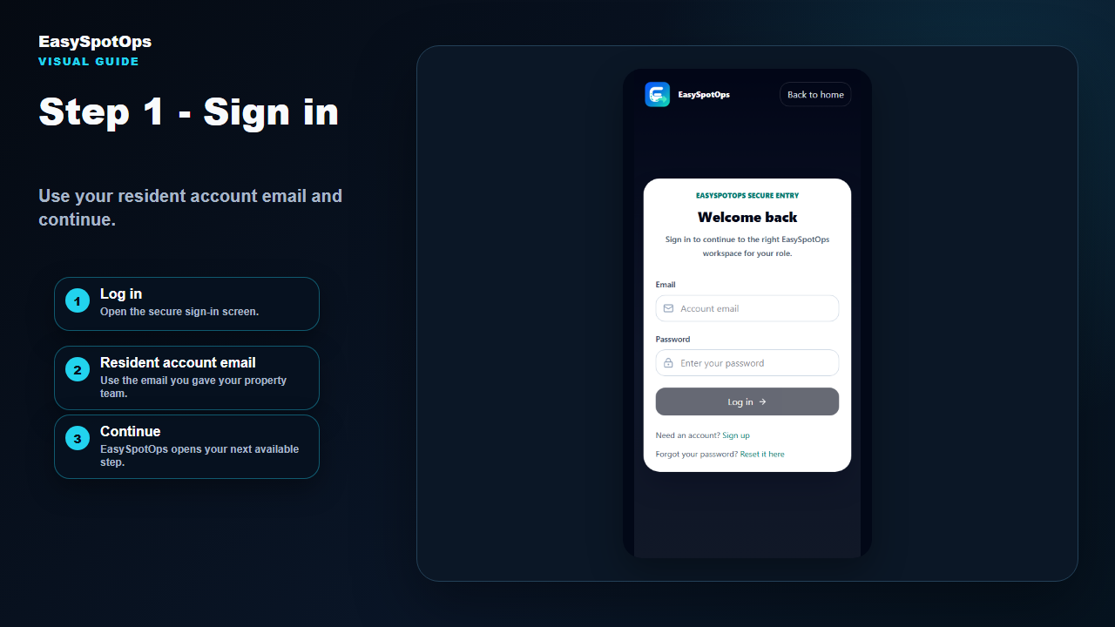
Screenshot or illustrated EasySpotOps product card with demo-safe sample data.
Look for this  Click Log in. | What to click  Use your resident account email. | What happens next  Continue to your dashboard or property access page.
What this section does
If you are not connected to a property yet, EasySpotOps may guide you to the property access page after sign-in.

Connecting to a property
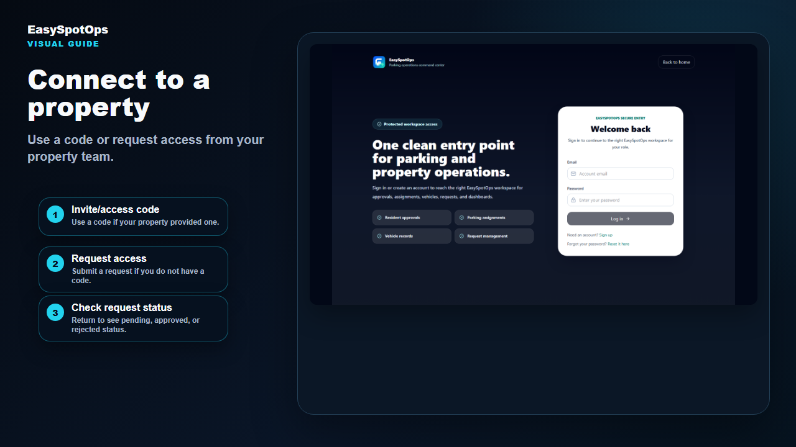
Screenshot or illustrated EasySpotOps product card with demo-safe sample data.
Look for this  Use a code if your property team provided one. | What to click  Request access if you do not have a code. | What happens next  Check status after submitting.
What this section does
You need an approved property connection before you can fully view your parking dashboard. Your property team reviews your request.

Using an invite/access code
Screenshot or illustrated EasySpotOps product card with demo-safe sample data.
Look for this  Enter the code exactly as provided. | What to click  Confirm the property shown is correct. | What happens next  Complete any required resident or vehicle details.
What this section does
If the code does not work, check for typing errors and confirm the code is still active. Contact your property team if the problem continues.

Requesting access
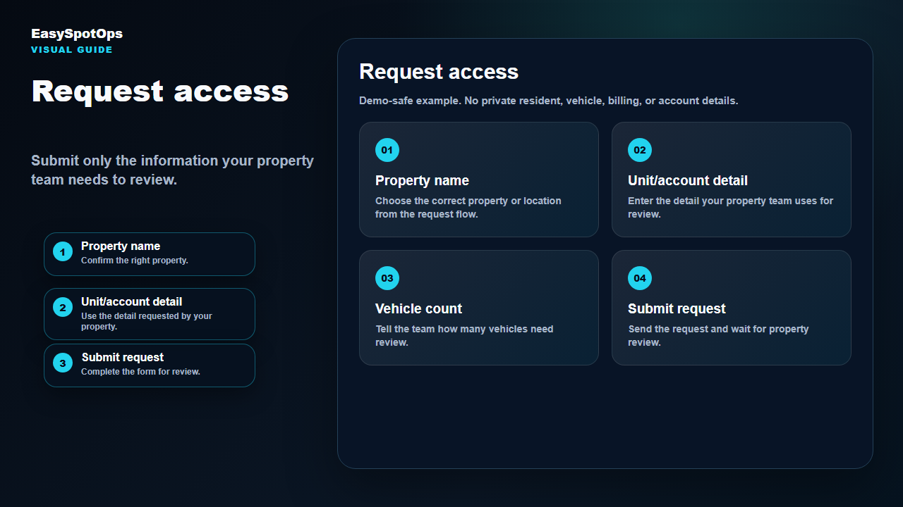
Screenshot or illustrated EasySpotOps product card with demo-safe sample data.
Look for this  Choose the correct property or location. | What to click  Add unit, room, account, or other requested detail. | What happens next  Submit complete vehicle information when asked.
What this section does
Complete information helps your property team review your request faster.

Checking request status
Screenshot or illustrated EasySpotOps product card with demo-safe sample data.
Look for this  Pending means review is not complete yet. | What to click  Approved means your resident dashboard is available. | What happens next  Rejected, expired, or disconnected may require follow-up.
What this section does
If your status does not look right, contact your property team and include the email address you used to sign in.

Registering a vehicle
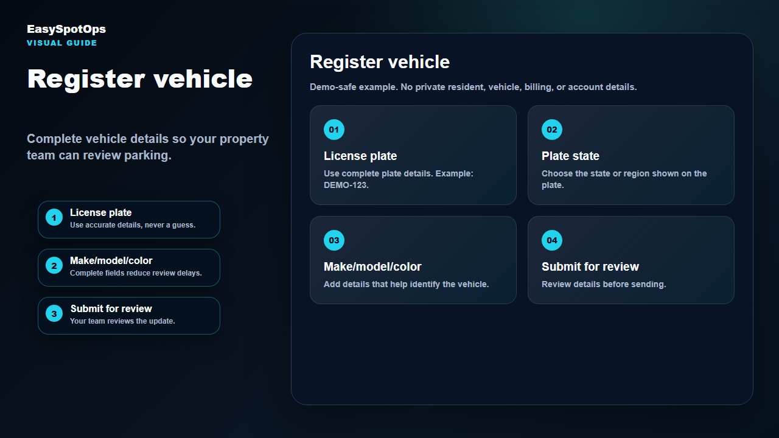
Screenshot or illustrated EasySpotOps product card with demo-safe sample data.
Look for this  Enter plate and state details carefully. | What to click  Add year, make, model, and color. | What happens next  Submit the update for review if required.
What this section does
Missing plate, state, make, model, or color information can delay review.

Viewing parking status
Screenshot or illustrated EasySpotOps product card with demo-safe sample data.
Look for this  Check property connection status. | What to click  Review vehicle status. | What happens next  Look for assigned space or spot.
What this section does
Your dashboard may show account status, property name, parking assignment, assigned space or spot, vehicle connected to the assignment, and recent request activity.

Submitting requests
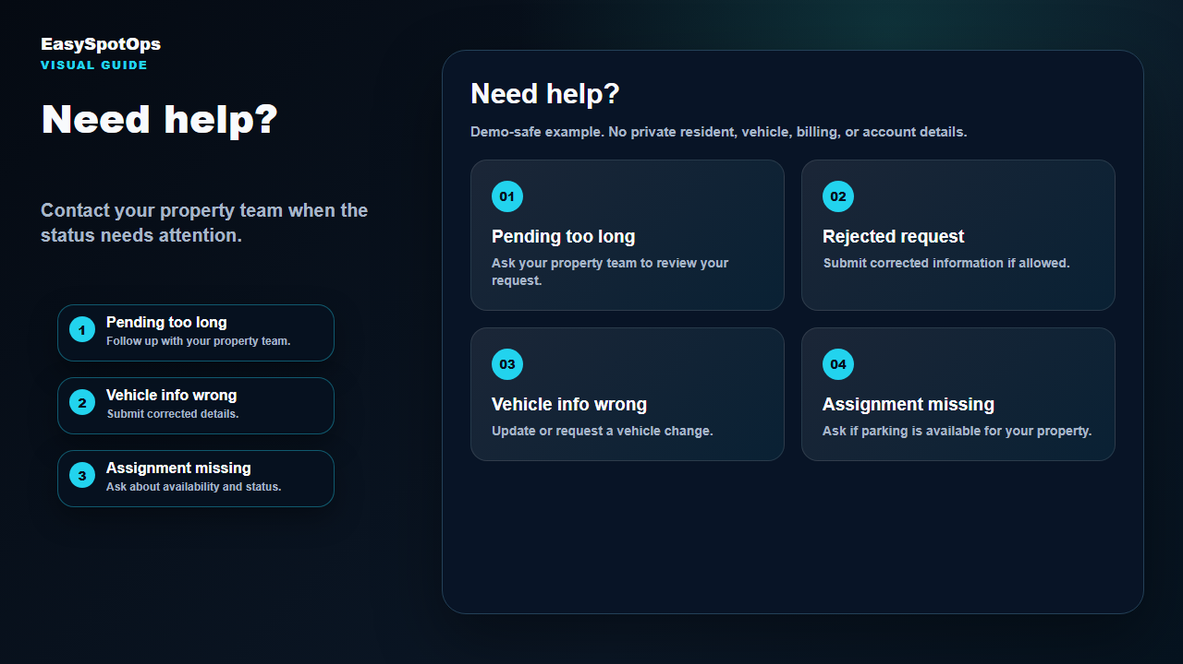
Screenshot or illustrated EasySpotOps product card with demo-safe sample data.
Look for this  Choose the request type. | What to click  Add a clear note. | What happens next  Check dashboard or request history for updates.
What this section does
If requests are enabled for your property, you may be able to submit parking, vehicle, access extension, or support requests.

Mobile tips
Screenshot or illustrated EasySpotOps product card with demo-safe sample data.
Look for this  Use a current mobile browser. | What to click  Keep your sign-in email handy. | What happens next  Double-check vehicle details before submitting.
What this section does
EasySpotOps is designed to work well from a phone. Use dashboard quick actions to open parking, vehicles, or requests.

Troubleshooting
Screenshot or illustrated EasySpotOps product card with demo-safe sample data.
Look for this  Follow up if pending longer than expected. | What to click  Correct information after a rejected request if allowed. | What happens next  Ask your property team when parking assignment is missing.
What this section does
Most issues are resolved by checking request status, confirming vehicle information, and contacting your property team with the email you used to sign in.
Thank you for using EasySpotOps.

