EasySpotOps
EasySpotOps Client User Manual
Visual guide for clients, property managers, owners, and operations teams managing parking operations.
Parking Operations Made Simple

Visual Step-by-Step Guide
- Welcome - what EasySpotOps does
- Sign in
- Client dashboard overview
- Managing residents and parkers
- Reviewing access requests
- Approving or rejecting residents
- Managing vehicles
- Managing parking spots
- Assigning parking
- Requests and communication
- Billing/account status overview
- Troubleshooting

Welcome - what EasySpotOps does
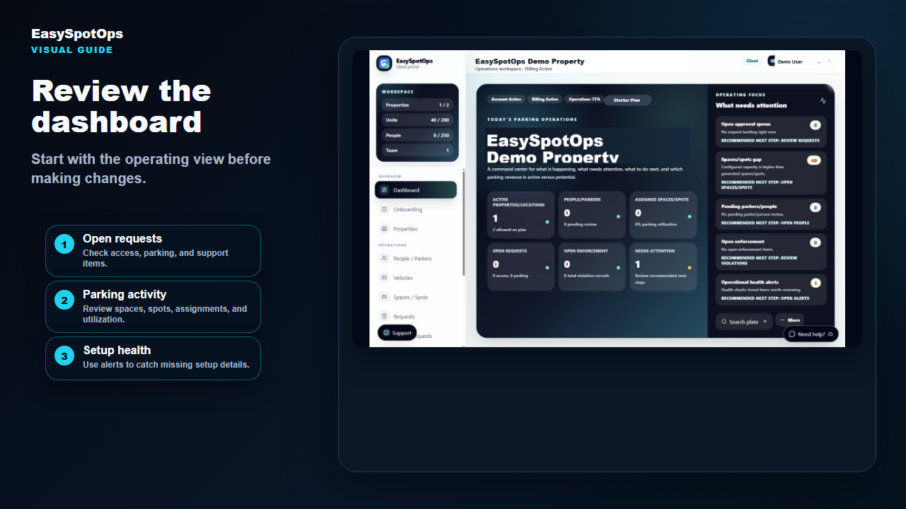
Screenshot or illustrated EasySpotOps product card with demo-safe sample data.
Look for this  Look for the workspace overview and operating focus. | What to click  Use one system for people, vehicles, requests, and parking assignments. | What happens next  Start with clean records before making parking changes.
What this section does
EasySpotOps helps properties and locations manage parking operations in one clean system. It supports property managers, owners, and operations teams that need one place for access review, vehicles, requests, spaces or spots, and assignments.
Use the dashboard first, then move into the area that needs action. This keeps daily work consistent and easier to audit.

Sign in
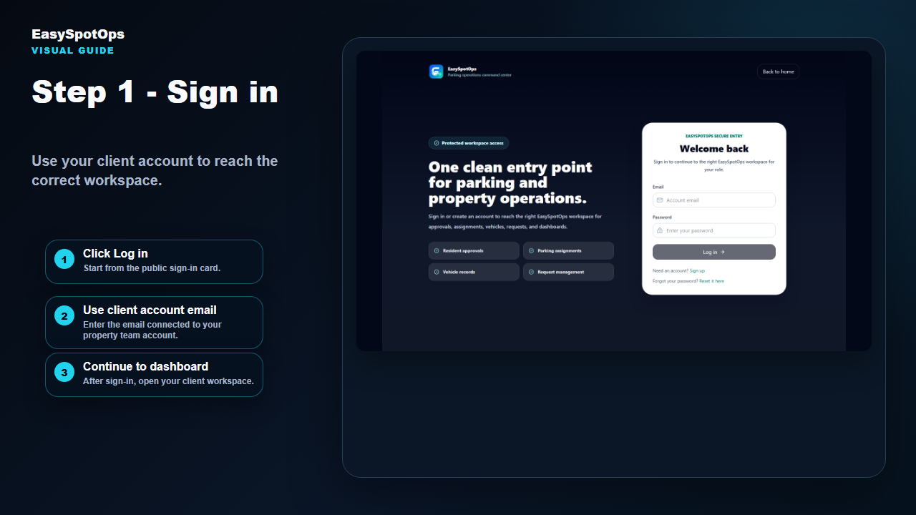
Screenshot or illustrated EasySpotOps product card with demo-safe sample data.
Look for this  Click Log in from the public sign-in screen. | What to click  Use the email connected to your client account. | What happens next  Open the correct client workspace after sign-in.
What this section does
If you manage more than one property or location, confirm you are viewing the correct one before approving access, changing vehicles, or assigning parking.

Client dashboard overview
Screenshot or illustrated EasySpotOps product card with demo-safe sample data.
Look for this  Review setup health and operating focus. | What to click  Check open requests and parking activity. | What happens next  Open spaces/spots, vehicles, or people from the dashboard.
What this section does
The dashboard is your daily parking operations home base. It helps you see open items, active assignments, available spaces or spots, request activity, and account status.

Managing residents and parkers
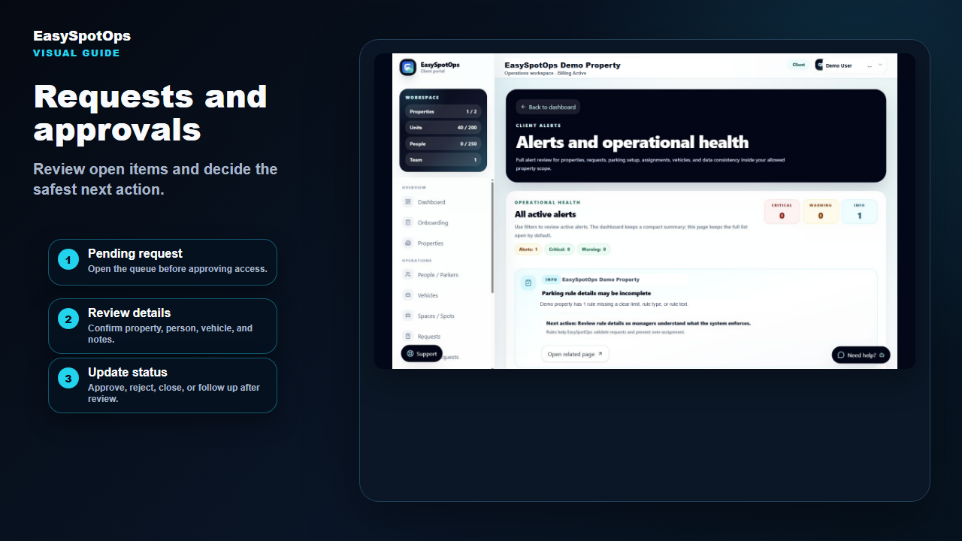
Screenshot or illustrated EasySpotOps product card with demo-safe sample data.
Look for this  Search by person, property, unit/account, vehicle, or status. | What to click  Open the detail view before taking action. | What happens next  Keep people records current before assigning parking.
What this section does
The people area helps you review residents, parkers, guests, staff, customers, owners, vendors, or other assigned users connected to a property or location.

Reviewing access requests
Screenshot or illustrated EasySpotOps product card with demo-safe sample data.
Look for this  Open new or pending requests first. | What to click  Confirm property, person, notes, and vehicle details. | What happens next  Contact the person if something is unclear.
What this section does
Access requests are submitted when someone asks to connect to a property. Review the request against your property records before making a decision.

Approving or rejecting residents
Screenshot or illustrated EasySpotOps product card with demo-safe sample data.
Look for this  Approve only when the person belongs to the property or location. | What to click  Reject requests that do not match your records. | What happens next  Ask for corrected information when details are missing.
What this section does
Approval gives the person access to the property workflow. Rejection closes the request and prevents the connection from becoming active.

Managing vehicles
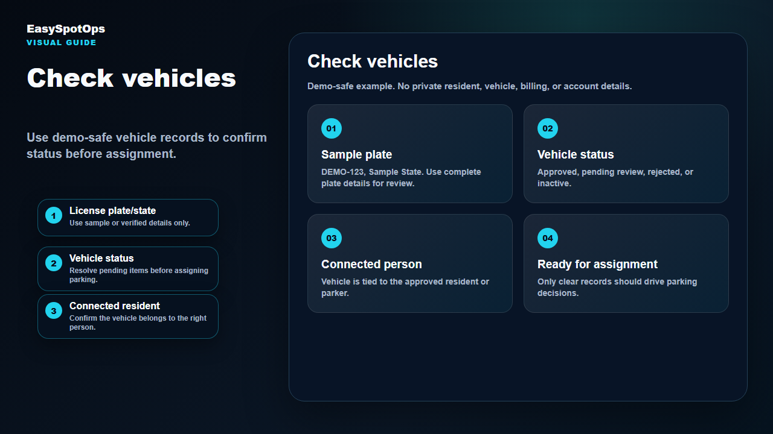
Screenshot or illustrated EasySpotOps product card with demo-safe sample data.
Look for this  Check plate and state details. | What to click  Review status before parking assignment. | What happens next  Confirm the vehicle is connected to the right person.
What this section does
Vehicle records may include plate, state, year, make, model, color, connected person, property or location, and review status. Do not assign parking until the vehicle record is clear enough for daily operations.

Managing parking spots
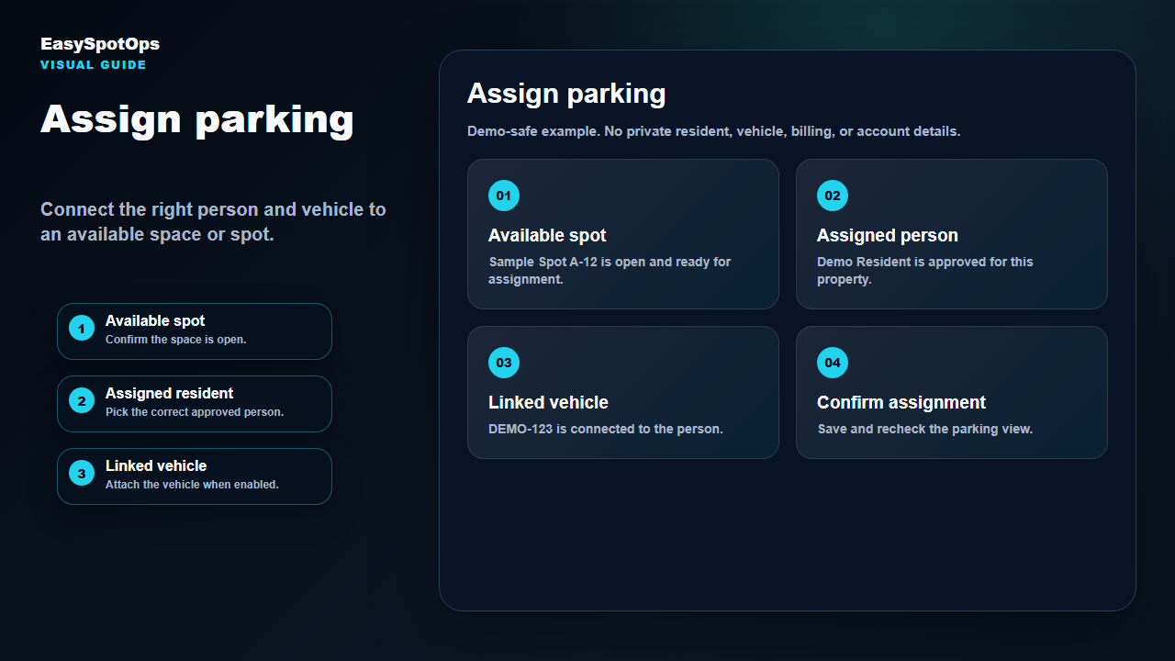
Screenshot or illustrated EasySpotOps product card with demo-safe sample data.
Look for this  Review total, available, and assigned spaces or spots. | What to click  Use spot labels, areas, or sections if enabled. | What happens next  Keep unavailable spots out of assignment decisions.
What this section does
The parking area is where teams review capacity, availability, and assignments. Confirm the correct property or location before changing spots.

Assigning parking
Screenshot or illustrated EasySpotOps product card with demo-safe sample data.
Look for this  Confirm the person is approved and active. | What to click  Select an available space or spot. | What happens next  Link the vehicle when that option is enabled.
What this section does
Parking assignment connects an approved person and, when available, a vehicle to a parking space or spot. Recheck the parking view after saving.

Requests and communication
Screenshot or illustrated EasySpotOps product card with demo-safe sample data.
Look for this  Check open access, parking, vehicle, and support requests. | What to click  Use status to prioritize review. | What happens next  Close or update requests after action.
What this section does
Requests help teams track work that needs review. Check the request queue daily so access and parking items do not get lost.

Billing/account status overview
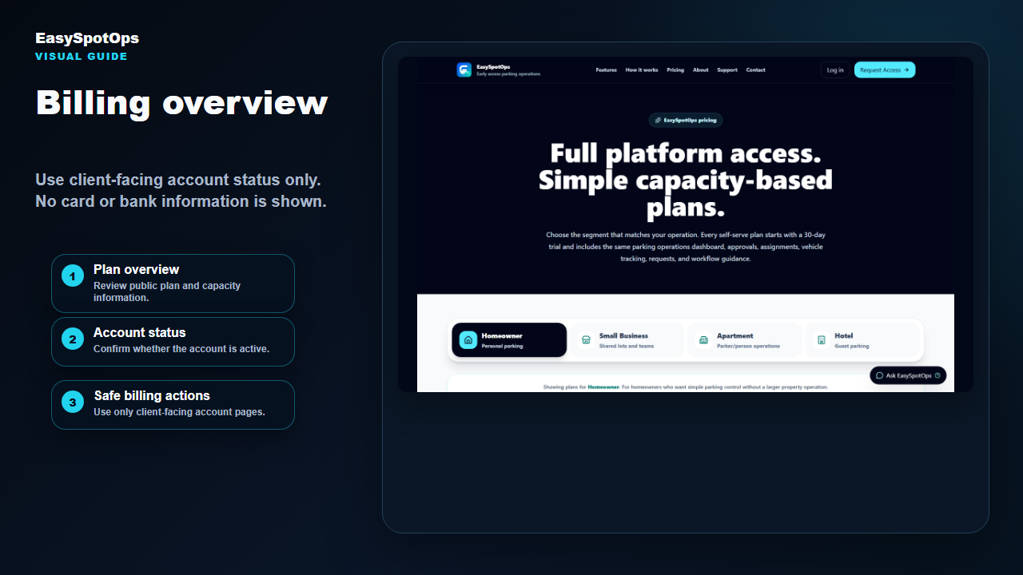
Screenshot or illustrated EasySpotOps product card with demo-safe sample data.
Look for this  Use client-facing account status only. | What to click  Look for active account status or plan information. | What happens next  No card or bank information is shown in this guide.
What this section does
Billing and account status should be reviewed only from the client-facing account page. Contact the account owner or EasySpotOps support when account status needs follow-up.

Troubleshooting
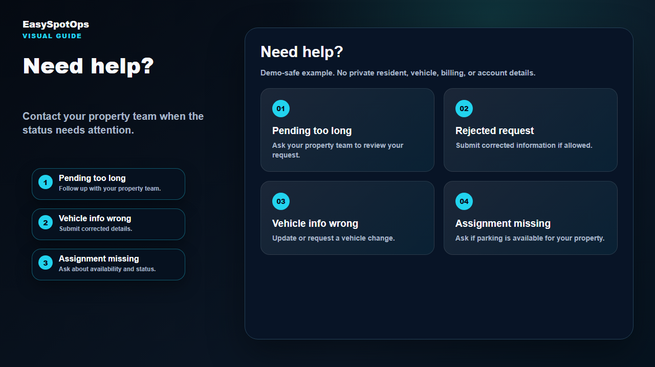
Screenshot or illustrated EasySpotOps product card with demo-safe sample data.
Look for this  Check whether the request is pending, approved, rejected, expired, or disconnected. | What to click  Verify property, person, vehicle, and spot details. | What happens next  Contact support when the issue cannot be resolved in the workflow.
What this section does
Most issues are resolved by confirming the correct property/location, reviewing the person and vehicle records, and checking the request status before assigning parking.
Thank you for using EasySpotOps.

